Q1) Matched Pairs

-"PT remaining"(it is expressed as a fraction in the data sheet) vs "QT 8cm remaining" vs "QT 6cm remaining":is there a statistically significant increase in the amount of tendon remaining -"QT graft volume" vs. "PT graft volume", is there a statistically significant increase and mean.

| Variable | N | Mean | Median | SD | P value  (Wilcoxon signed rank sum test) |
| --- | --- | --- | --- | --- | --- |
| PT_remaining | 54 | 0.5668 | 0.5702 | 0.0477 | - |
| QT_6cm_remaining | 54 | 0.6347 | 0.6449 | 0.0480 | - |
| QT_8cm_remaining | 60 | 0.6131 | 0.6167 | 0.0482 | - |
| PT_graft_volume | 53 | 1.0971 | 1.0624 | 0.1929 | - |
| QT_graft_volume | 53 | 2.0215 | 1.9502 | 0.4178 | - |
| PT_remaining - QT_6cm_remaining | 54 | -0.0679 | -0.0676 | 0.0565 | <0.0001 |
| PT_remaining - QT_8cm_remaining | 54 | -0.0457 | -0.0393 | 0.0586 | <0.0001 |
| PT_graft_volume - QT_graft_volume | 53 | -0.9244 | -0.8892 | 0.4033 | <0.0001 |

Q2) Correlation/predictive value:

-height/weight/sex/age/BMI vs "PT length" and "QT length", which are significant/Pearson correlation coefficients/linear regression of most highly correlated (separated by sex it proves to be predictive).

Spearman Correlation (p value):

|  |  |  |  |  |  |  |  |
| --- | --- | --- | --- | --- | --- | --- | --- |
| Variable | Height | Weight | Age | BMI | Gender  (Wilcoxon-Mann-Whitney test) | | |
| PT length | 0.5469  (p<0.0001) | 0.2612  (p=0.061) | -0.21871  (p=0.12) | 0.00030  (p=1.00) |  | Mean ±SD | P value |
| Female | 42.2±4.6 | 0.011 |
| Male | 46.2±5.8 |
| QT length | 0.4999  (p<0.0001) | 0.3376  (p=0.0089) | -0.14289  (p=0.28) | 0.06973  (p=0.60) | Female | 73.5±12.3 | 0.010 |
| Male | 81.1±10.6 |

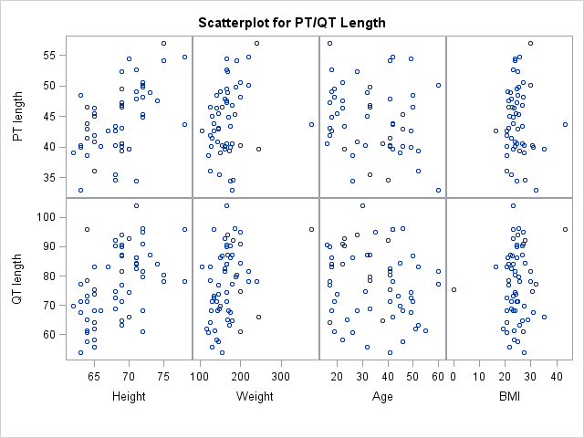

Q3) post ANOVA analysis with either Tukey Kramer or Bonferroni of "Height category" vs "PT length" and "QT length"

1. Test for PT_length

| **Comparisons significant at the 0.05 level are indicated by ***.** | | | | |
| --- | --- | --- | --- | --- |
| **Height Comparison** | **Difference Between Means** | **Simultaneous 95% Confidence Limits** | |  |
| **D - C** | 4.633 | -2.090 | 11.356 |  |
| **D - B** | 8.799 | 2.234 | 15.364 | *** |
| **D - A** | 9.578 | 2.966 | 16.189 | *** |
| **C - B** | 4.166 | -0.491 | 8.823 |  |
| **C - A** | 4.945 | 0.222 | 9.667 | *** |
| **B - A** | 0.779 | -3.716 | 5.274 |  |

| Least Squares Means for effect Height Pr > |t| for H0: LSMean(i)=LSMean(j), Dependent Variable: PT_length | | | | |
| --- | --- | --- | --- | --- |
| i/j | A | B | C | D |
| A |  | 0.9671 | 0.0369 | 0.0019 |
| B | 0.9671 |  | 0.0946 | 0.0045 |
| C | 0.0369 | 0.0946 |  | 0.2704 |
| D | 0.0019 | 0.0045 | 0.2704 |  |

1. Test for QT_length

| **Comparisons significant at the 0.05 level are indicated by ***.** | | | | |
| --- | --- | --- | --- | --- |
| **Height Comparison** | **Difference Between Means** | **Simultaneous 95% Confidence Limits** | |  |
| **C - D** | 0.199 | -13.745 | 14.143 |  |
| **C - B** | 3.741 | -5.660 | 13.142 |  |
| **C - A** | 14.773 | 5.831 | 23.715 | *** |
| **D - B** | 3.542 | -10.402 | 17.487 |  |
| **D - A** | 14.574 | 0.935 | 28.213 | *** |
| **B - A** | 11.032 | 2.090 | 19.974 | *** |

| Least Squares Means for effect Height Pr > |t| for H0: LSMean(i)=LSMean(j), Dependent Variable: PT_length | | | | |
| --- | --- | --- | --- | --- |
| i/j | A | B | C | D |
| A |  | 0.0098 | 0.0003 | 0.0319 |
| B | 0.0098 |  | 0.7187 | 0.9070 |
| C | 0.0003 | 0.7187 |  | 1.0000 |
| D | 0.0319 | 0.9070 | 1.0000 | 0.0319 |

Q4) Correlation/predictive value of category "3cm sag" against "QT length", "QT thick at 6 cm", and QT "graft volume"

| **Variable** | **N** | **Mean** | **Std Dev** | **Median** | **Minimum** | **Maximum** | **Label** |
| --- | --- | --- | --- | --- | --- | --- | --- |
| **QT_length** | 60 | 77.3117 | 11.9887 | 77.6500 | 53.9000 | 104.0000 | QT length |
| **QT_thick_at_6** | 60 | 7.0801 | 1.5921 | 6.8583 | 4.2467 | 11.5100 | QT thick at 6 |
| **QT_graft_volume** | 53 | 2.0215 | 0.4178 | 1.9502 | 1.3199 | 3.2604 | QT graft volume |
| **3cm_sag** | 53 | 7.4208 | 1.2826 | 7.2000 | 5.3000 | 11.6000 | 3cm sag |

Spearman Correlation (p value):

|  |  |  |  |
| --- | --- | --- | --- |
| Variable | **QT_length** | **QT_thick_at_6cm** | **QT_graft_volume** |
| **3cm sag** | 0.00500 (p=0.97) | 0.76956 (p<0.0001) | 0.80446 (p<0.0001) |

Linear Regression:

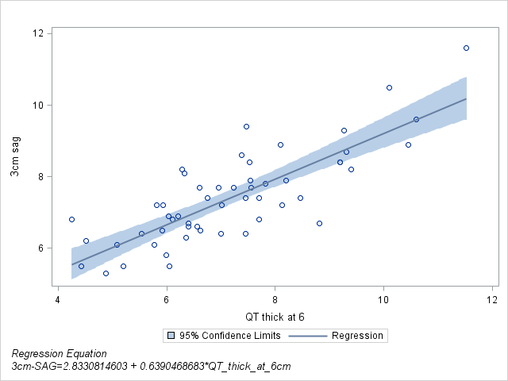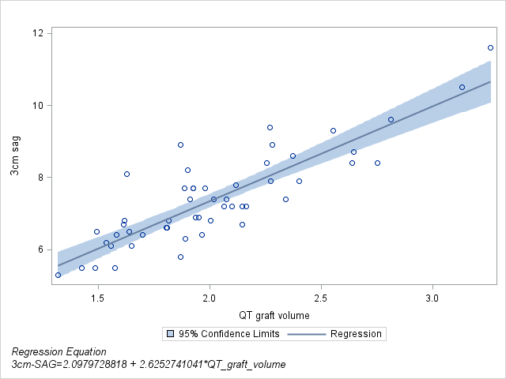

Q5) Means, SD, and 95% confidence intervals of columns (S, T and U)

| **Variable** | **Label** | **N** | **Mean** | **Std Dev** | **Lower 95% CL for Mean** | **Upper 95% CL for Mean** |
| --- | --- | --- | --- | --- | --- | --- |
| |  | | --- | | **thick31** | | **thick61** | | **thick63** | | |  | | --- | | **3-1 thickness** | | **6-1 thickness** | | **6-3 thickness** | | |  | | --- | | 60 | | 60 | | 60 | | |  | | --- | | 1.0021748 | | 0.9623240 | | 0.9594527 | | |  | | --- | | 0.1096618 | | 0.1634271 | | 0.1217282 | | |  | | --- | | 0.9738462 | | 0.9201063 | | 0.9280069 | | |  | | --- | | 1.0305034 | | 1.0045417 | | 0.9908984 | |